Group 17: Miniproject 01 Report

Abhigyan Kishor(abk171), Saleh Almutairi(saa451), Quinn K Wolter(Qkw3)

VM IPs:

128.105.146.176(Public)

10.254.0.219(VM1),

10.254.3.84(VM2),

10.254.3.170(VM3)

Hadoop in Docker:

Jps

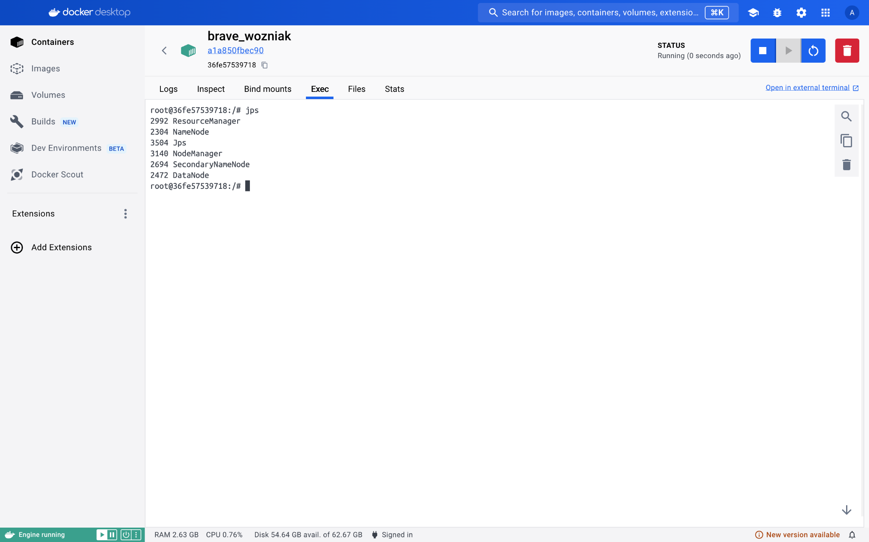

Hdfs working

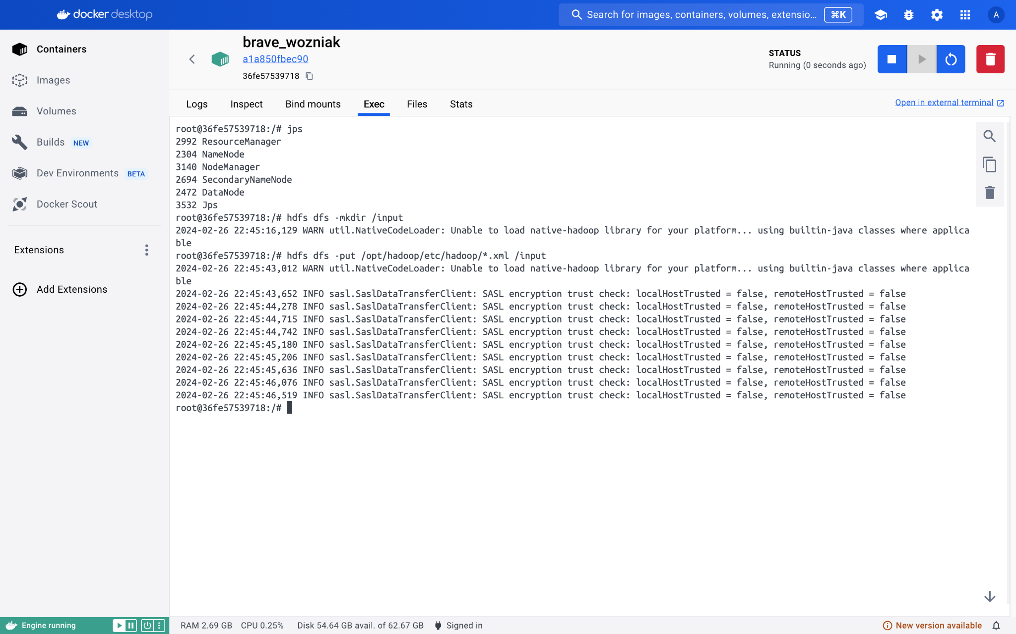

Testing examples:

Hadoop jar /opt/hadoop/share/hadoop/mapreduce/hadoop-mapreduce-examples.3.2.1.jar wordcount /input /output

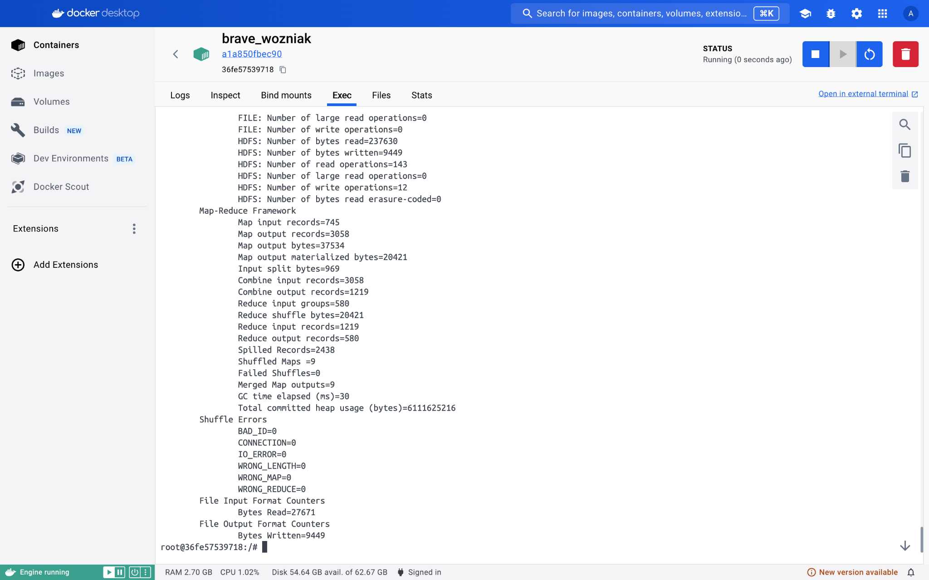

Output:

Hdfs dfs -cat /output/*

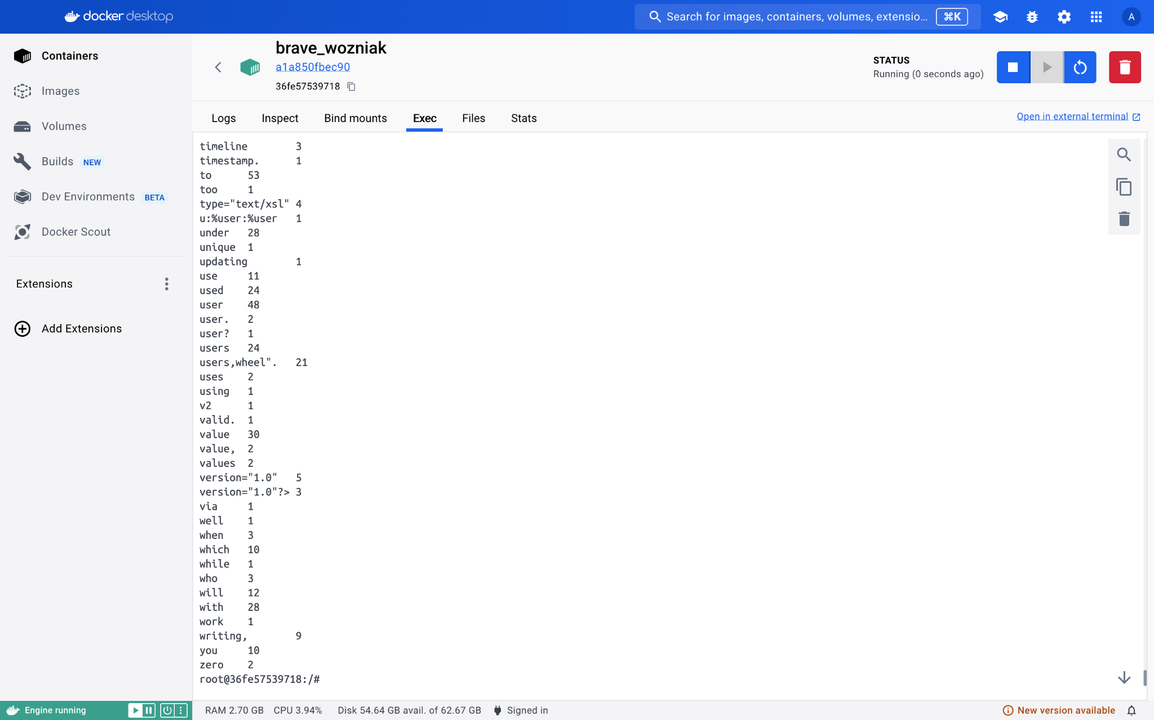

Hadoop in cluster:

Namenode

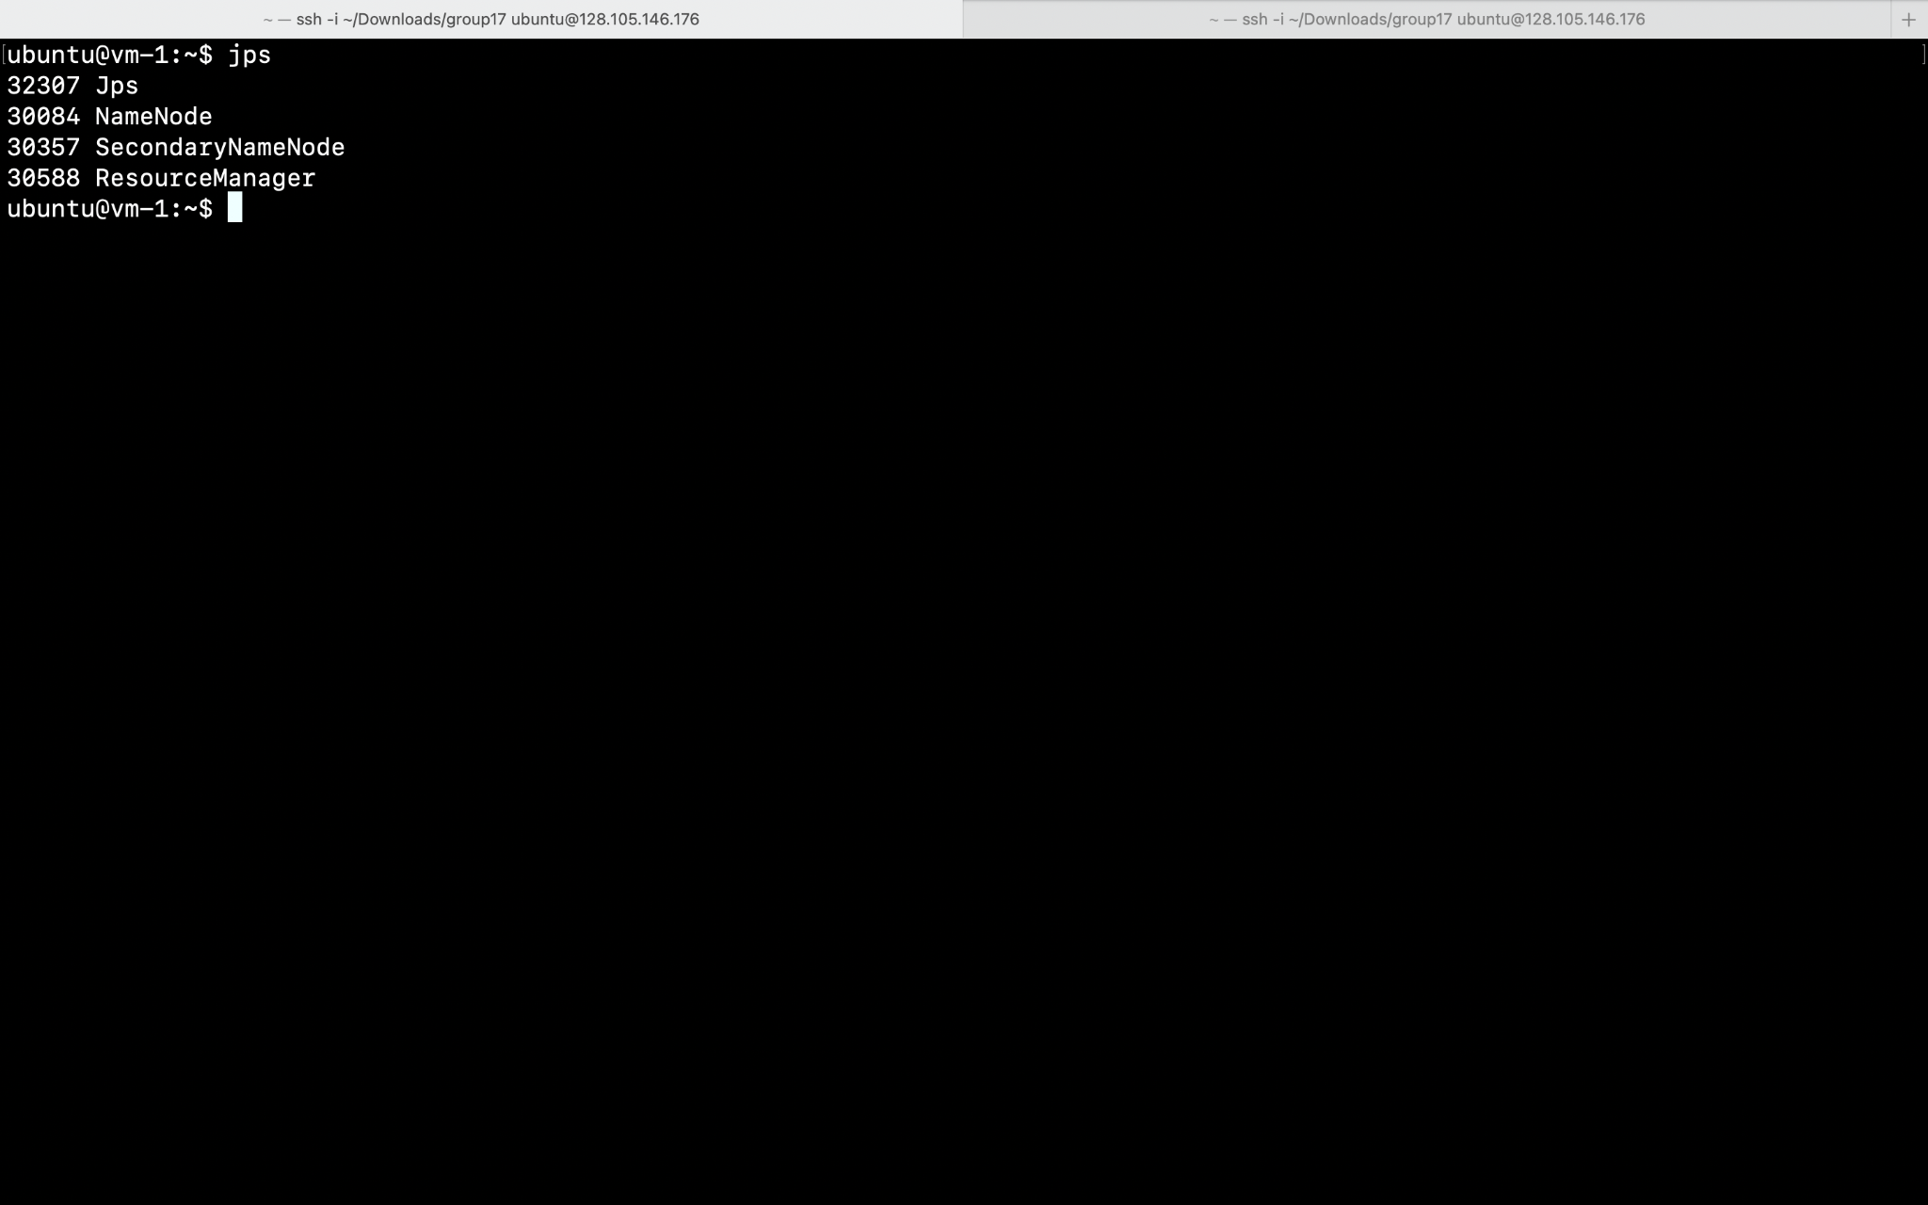

Vm2

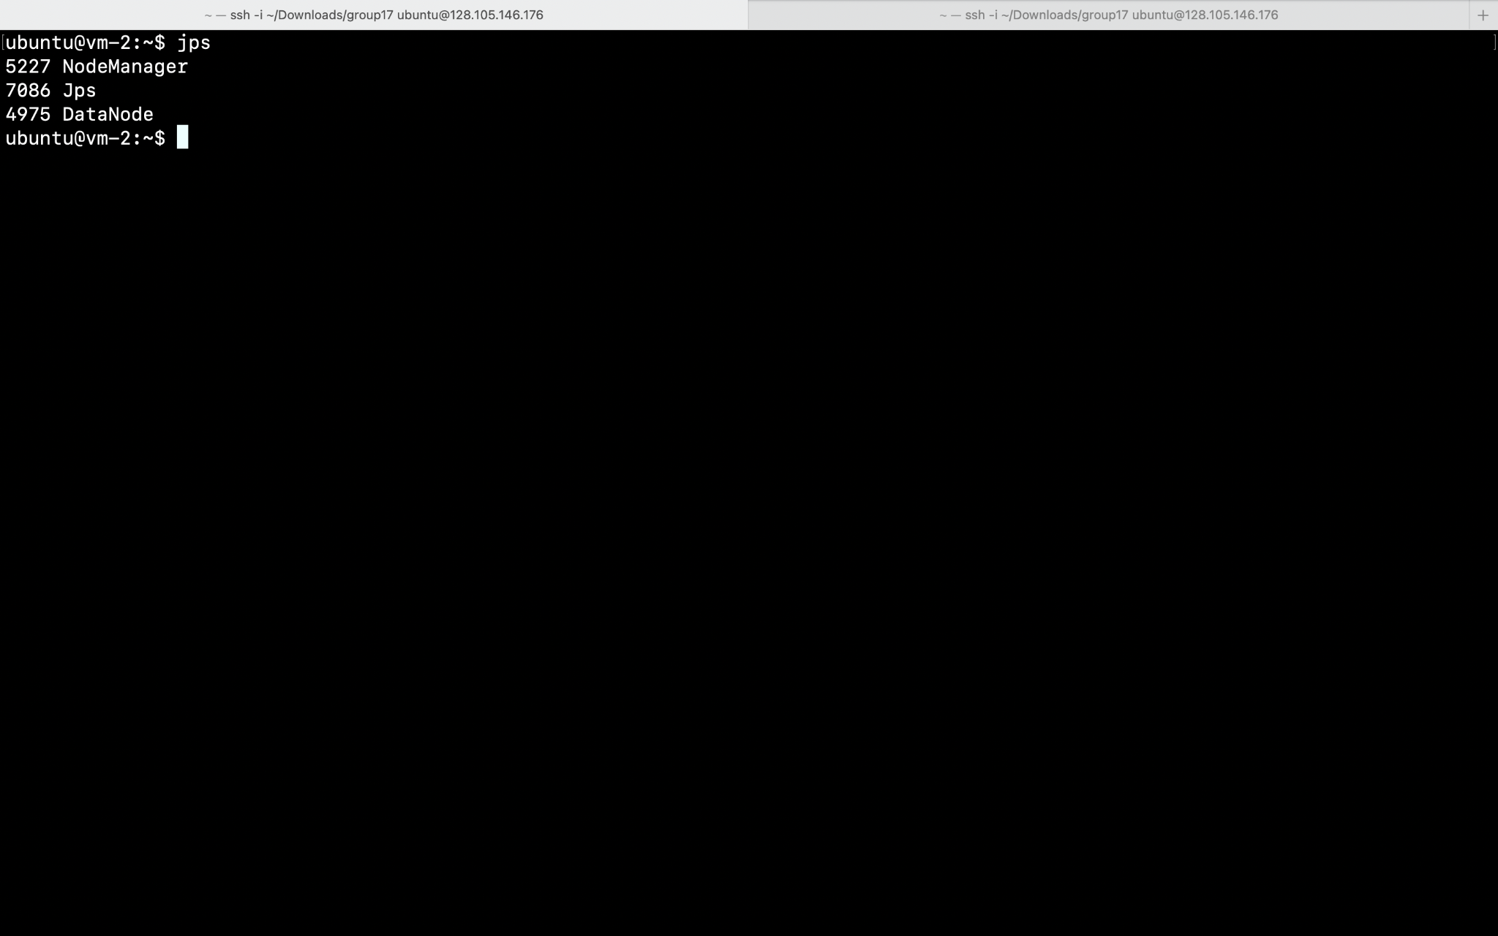

Vm3

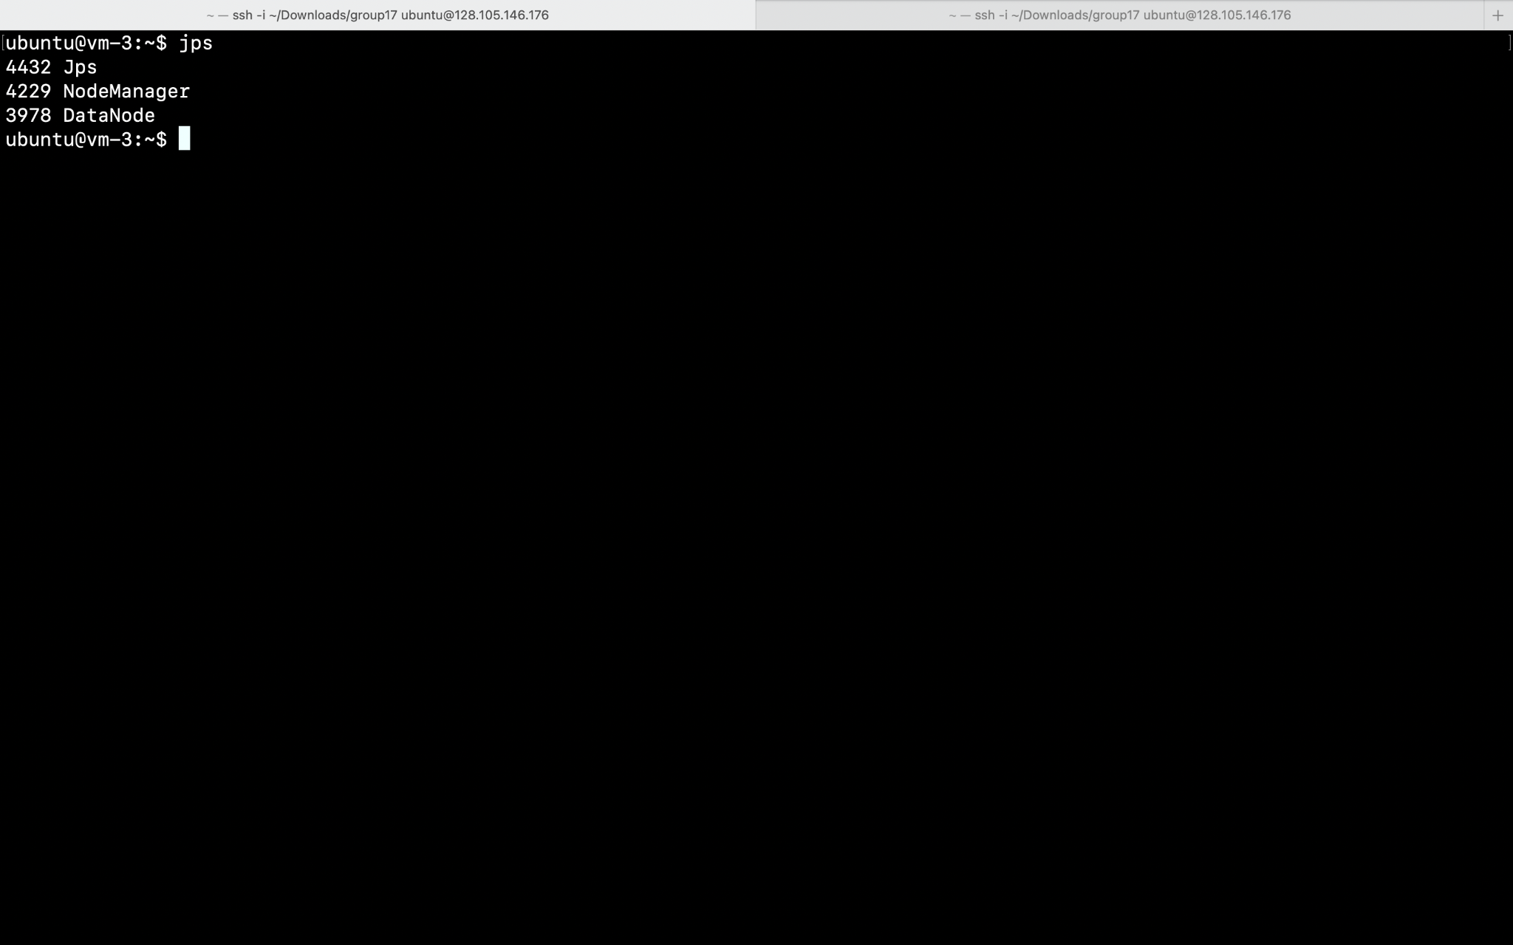

Q2.

hadoop jar ngram.jar ngram /q2input /output 3

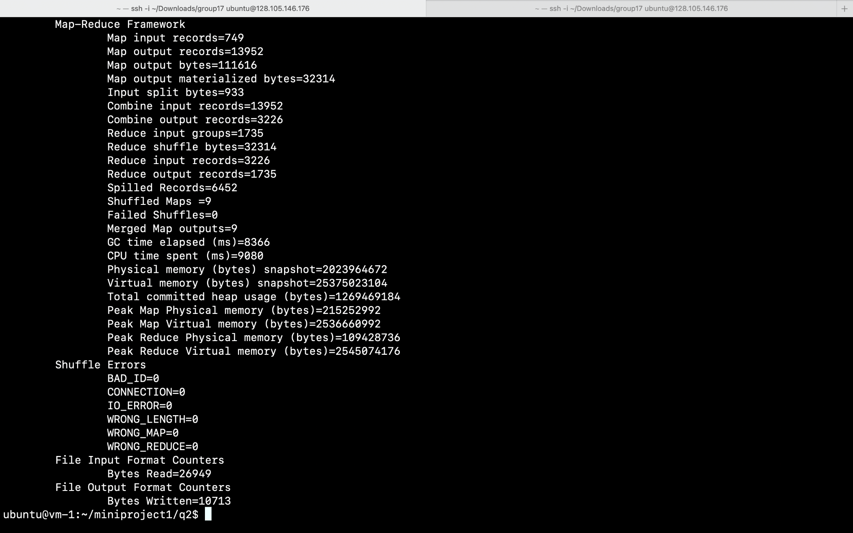

hdfs dfs -cat /output/*

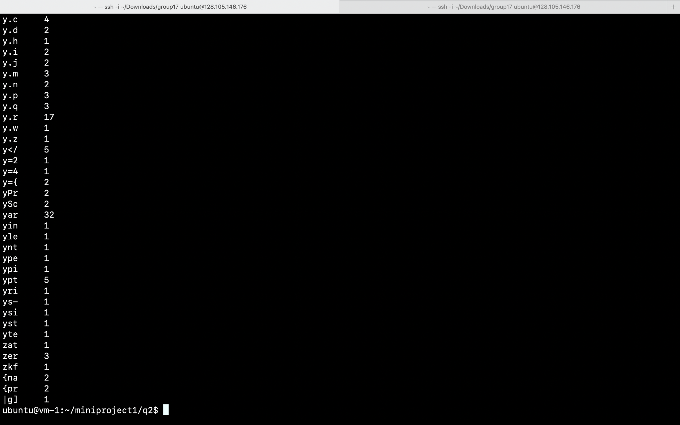

Working with randomtextwriter

hadoop jar ~/hadoop/share/hadoop/mapreduce/hadoop-mapreduce-examples-3.2.1.jar randomtextwriter /rtinput

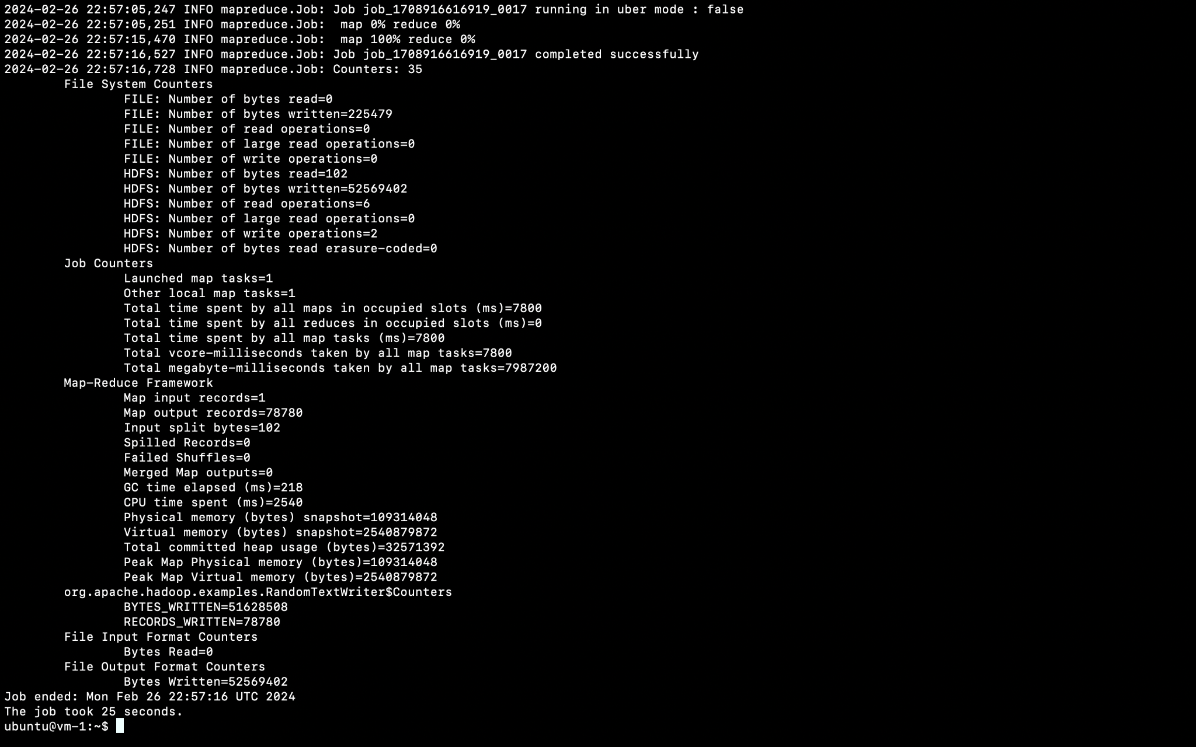

Running ngram.jar on rtinput

hadoop jar miniproject1/q2/ngram.jar ngram /rtinput /rtoutput 4

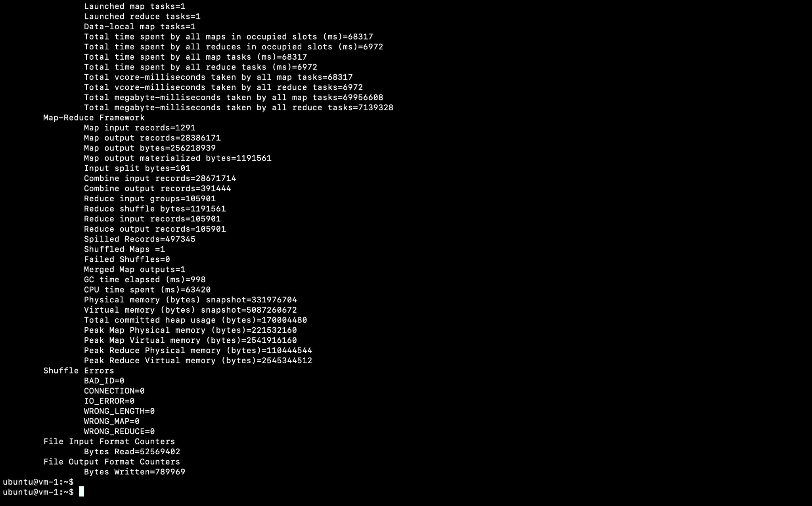

Hdfs dfs -cat /rtoutput/*



Q3 - P1

~/hadoop/bin/hadoop jar ./SmiliesHitCounterJob.jar SmiliesHitCounterJob /q3input/ /p1/

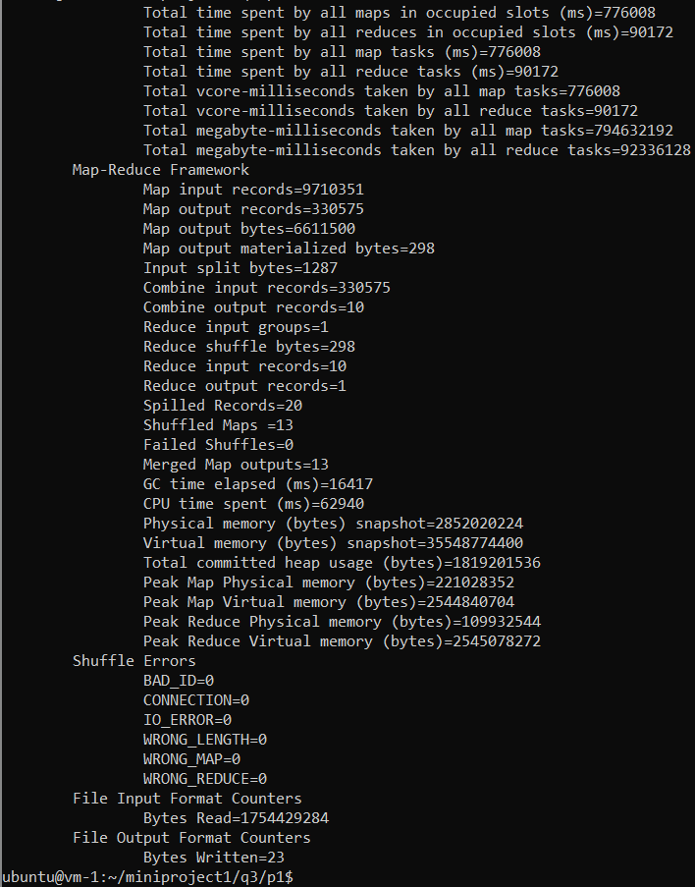

~/hadoop/bin/hdfs dfs -cat /p1/*



**There were 330,575 hits to “/images/smilies”**

Q3 - P2

~/hadoop/bin/hadoop jar ./IPHitCounterJob.jar IPHitCounterJob /q3input/ /p2/  
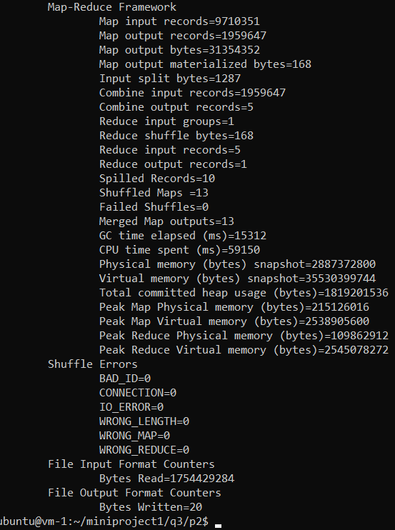  
~/hadoop/bin/hdfs dfs -cat /p2/*



**There were 1,959,647 hits from the IP Address 96.32.128.5**

Q3 - P3

~/hadoop/bin/hadoop jar ./RequestMethodCounterJob.jar RequestMethodCounterJob /q3input/ /p3/

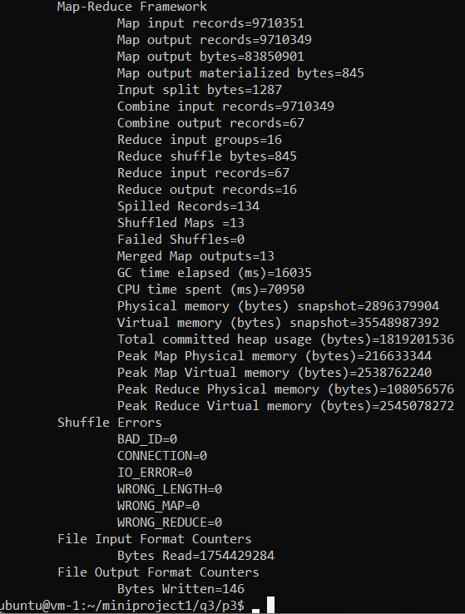

~/hadoop/bin/hdfs dfs -cat /p3/*

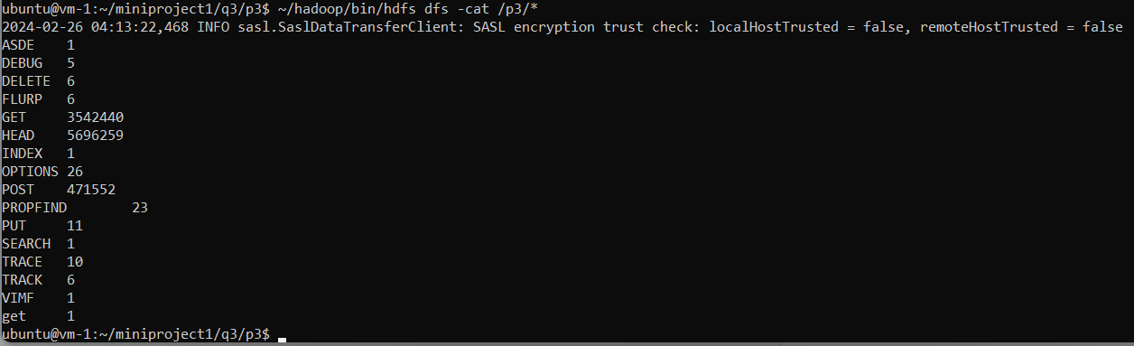

**There were 5,696,259 HEAD requests, 3,542,441 GET requests, and 471,552 POST requests, along with a medley of other request types.**

Q3 - P4

~/hadoop/bin/hadoop jar ./MostHitPathJob.jar MostHitPathJob /q3input/ /p4/

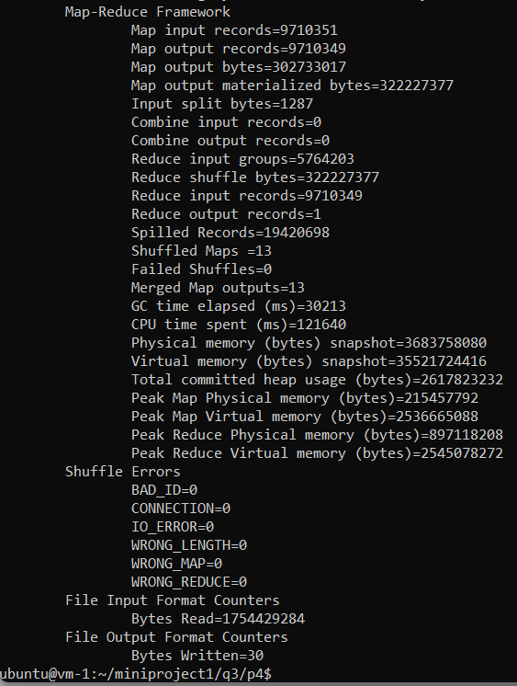

~/hadoop/bin/hdfs dfs -cat /p4/*



**The most hit path was “apache-log/access.log” with 63,006 hits.**

Q3 - P5

~/hadoop/bin/hadoop jar ./MostFrequentIPJob.jar MostFrequentIPJob /q3input/ /p5/

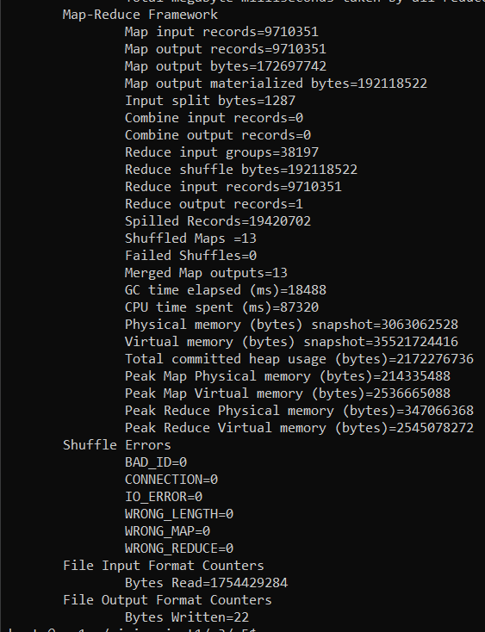

~/hadoop/bin/hdfs dfs -cat /p5/*



**The most prolific source of IP traffic was from 47.39.156.135 with 4,305,147 accesses.**

Q3 - P6

~/hadoop/bin/hadoop jar ./PostRequestCounterJob.jar PostRequestCounterJob /q3input/ /p6/

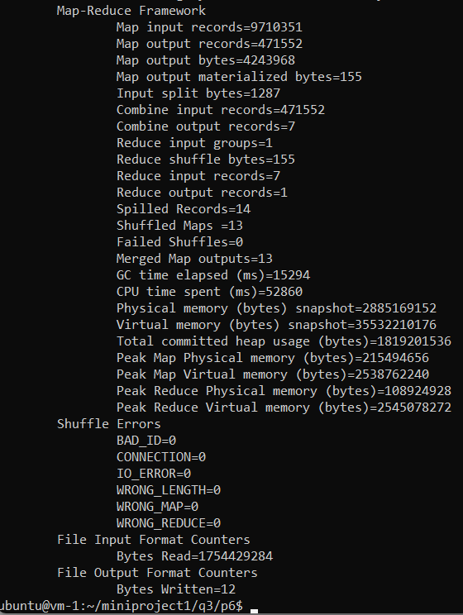

~/hadoop/bin/hdfs dfs -cat /p6/*



**There were 471,552 POST requests.**

Q3 - P7

~/hadoop/bin/hadoop jar ./Status404CounterJob.jar Status404CounterJob /q3input/ /p7/

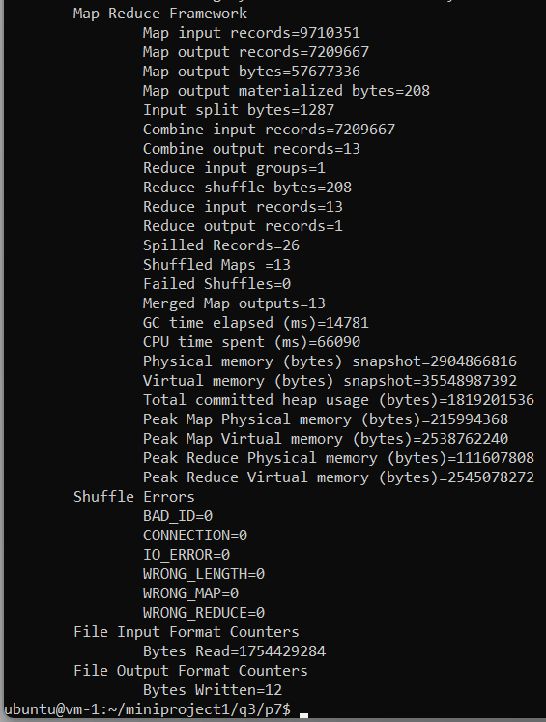

~/hadoop/bin/hdfs dfs -cat /p7/*



**7,209,667 requests threw a 404 error.**

Q3 - P8

~/hadoop/bin/hadoop jar ./DataRequestedOnDateJob.jar DataRequestedOnDateJob /q3input/ /p8/

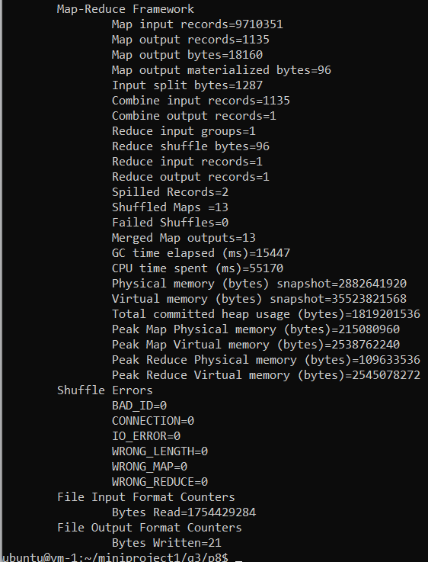

~/hadoop/bin/hdfs dfs -cat /p8/*



**10,337,151 bytes of data were requested on the 19th of December, 2020.**

Q3 - P9-1

~/hadoop/bin/hadoop jar TotalDataPerIPJob.jar TotalDataPerIPJob /q3input/ /p9-1/

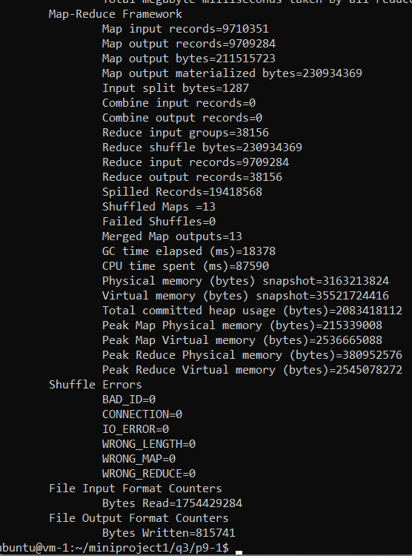

~/hadoop/bin/hdfs dfs -cat /p9-1/*

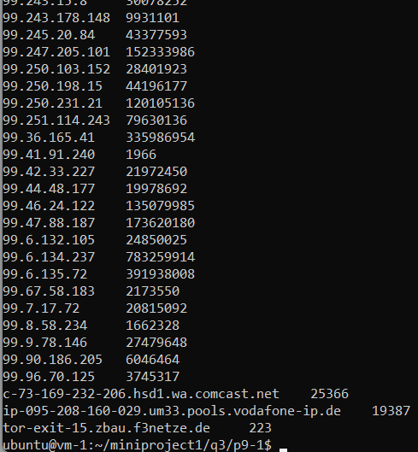

**For this problem, we had to run two separate MapReduce operations. The first retrieved all IPs and the number of hits associated with them…**

~/hadoop/bin/hdfs dfs -cat /p9-1/* > ~/p9-1.txt

~hadoop/bin/hadoop fs -copyFromLocal ~/p9-1.txt /q3input-p9/

Q3 - P9-2

~/hadoop/bin/hadoop jar TopThreeIPsJob.jar TopThreeIPsJob /q3input-p9/ /p9-2/

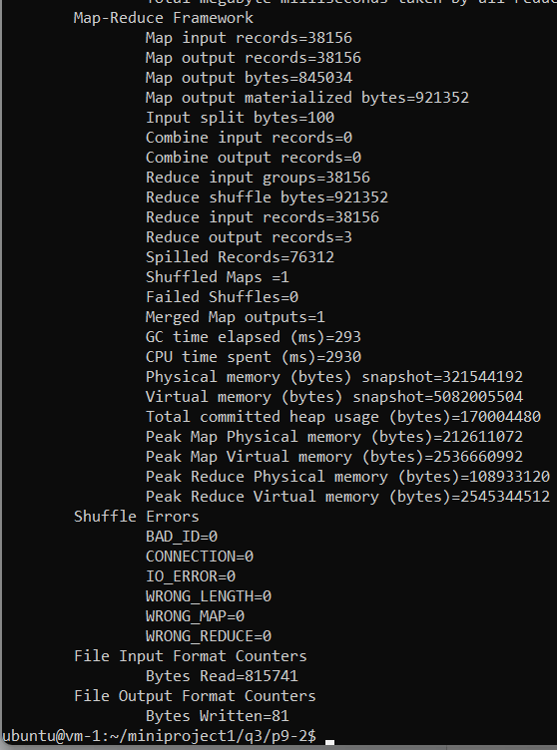

~/hadoop/bin/hdfs dfs -cat /p9-2/*



**And the next found the top three from the pile of data, giving us the impressive data flow numbers pictured above.**

Q3 - P10

~/hadoop/bin/hadoop jar Data200RequestedOnDateJob.jar Data200RequestedOnDateJob /q3input/ /p10/

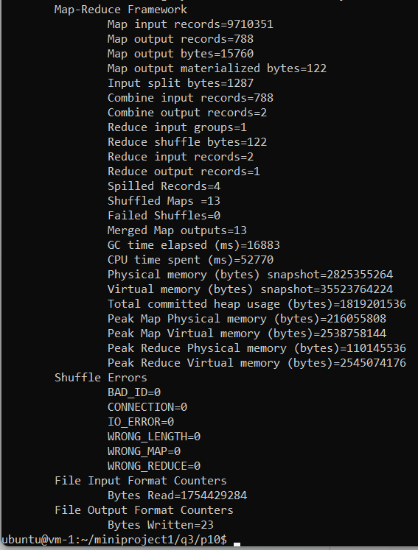

~/hadoop/bin/hdfs dfs -cat /p10/*



**Finally, we had 2465568761 bytes of data transferred in requests with a status of 200 “OK” on the 16th of January, 2022.**